Presented by: Carrie Peter
Parcelninja
49 Galaxy Avenue | Linbro business park

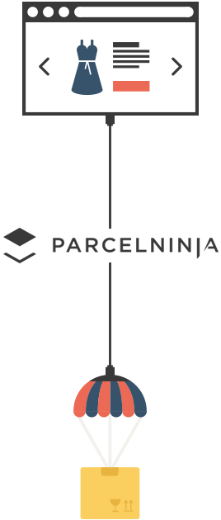

Parcelninja API Integration Overview
February 2017
Version 0.1
June 14, 2016

Parcelninja API Integration Overview

The Solution
Online shoppers decide to go online to shop for a number of reasons; they do not want to, or cannot go in-store to purchase the products, the ease of shopping online, or for the cost benefits. With this in mind, it is easy to see why online orders need to be fulfilled in the most cost effective, seamless and hassle-free way.
Many ecommerce businesses do not have the experience or economies of scale to offer the full service customers expect when shopping online.

The Online Shoppers Journey
A shopper has two main transactions with the client;
- making a purchase
- making a return
They can also make changes to their order. In order to ensure that the shopper does not feel the distinction between the two suppliers, all of the product information and order management activities will be handled by the client.

Fulfilling a Customers Order
Parcelninja allows the client to outsource the holding and dispatching of their stock to their online shoppers.
There are two ways a client can manage their Parcelninja inbound and outbound activities;
- manually through the self-service web interface and/or
- automatically via the web API
Inbound activities refer to anything that adds to the stock on hand in the warehouse. Outbound activities refer to anything that decreases the stock on hand.
The online shoppers journey should appear seamless despite it being split between the client and Parcelninja.
Online shopper journey & Division of responsibility during order life cycle

Parcelninja Services
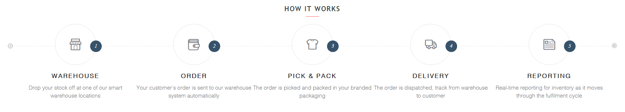
Parcelninja fulfilment activities
In short Parcelninja handles the physical fulfilment of below steps in the client’s ecommerce business.
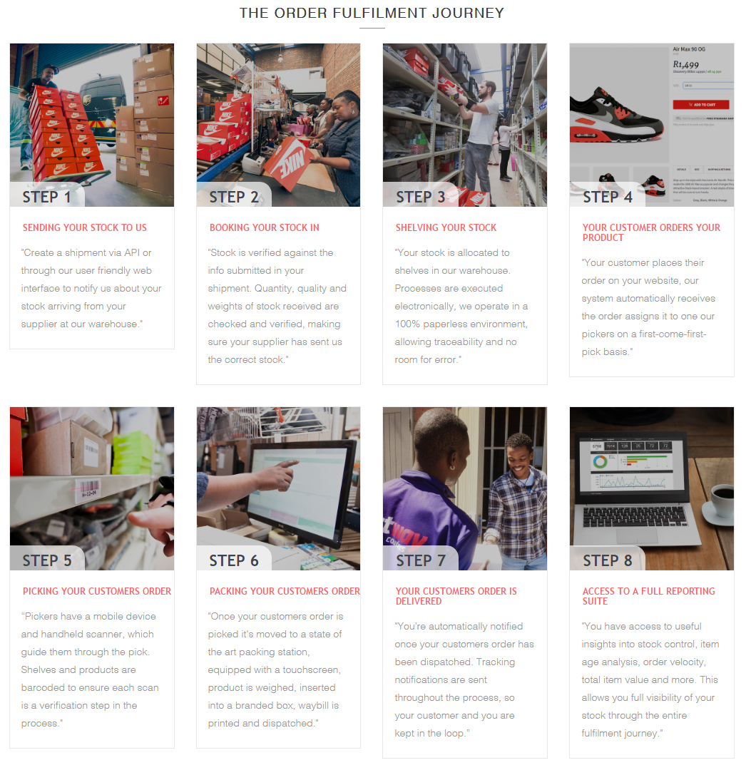
Order fulfilment journey

Parcelninja and Your Business

How do I Use Parcelninja?
When deciding to use Parcelninja the first decision should be whether to use the self-service web interface or the web API. The API is generally used when expected order volumes will exceed what can be managed through the web front-end.

What is a Web Front-end?
A web front-end, or self-service web interface is the presentation layer (the front end) between the user and the data access layer (the back end). Simply it is a webpage where a user can log in and interact with the system to achieve the desired outcome.

Parcelninja Web Interface
The Parcelninja web interface can be found at https://beta.parcelninja.co.za/login it requires a login name and password to access get in and manage a Parcelninja account. Once a user is logged in they will be able to create and inbound or outbound request, check inventory or view the account dashboard.

What is an API?
An application programming interface (API) is a set of routine definitions, protocols, and tools for building software and applications. In short, an API details what operations, information inputs and outputs are required in order to interact with the specific functionality required. It can be imagined as the specific key that unlocks a chosen door. An API allows developers to write code that interfaces with other software.

Parcelninja API
The Parcelninja API functionality directly matches the functionality available on the web but will allow the business to automatically manage outbound and inbound creation, stock levels & tracking data.
Using the Parcelninja API affords the following additional benefits:
- Professional stock holding, picking and packing.
- User can search their address using Parcelninja information, which will help to ensure correct delivery.
- Courier quoting, and tracking are simplified by Parcelninja algorithms.

Where We Fit Into Your Business?
When a client makes a product available for sale online, they need to be able to get those products to their shoppers. In order to get the right order to the right shopper in good time Parcelninja needs to have the products, know which ones need to be sent, and to where.
Essentially the following conditions need to be met:
- Products must be in stock
- Which products are in a shopper order
- Order destination
To ensure that the products are in stock it needs to get to Parcelninja, in the correct quantity, not broken, and can be tracked. To get stock to Parcelninja a client will create an inbound request – notifying Parcelninja that stock is on its way.
Once stock has arrived it needs to be inventoried and checked. Parcelninja will make sure that what the supplier sent, matches what the client ordered and that nothing is broken. If the products are not packaged properly, for a fee Parcelninja will package it for delivery so that it won’t break.
To get the products to the shopper an outbound request is sent to Parcelninja detailing what needs to be sent to where and who will be receiving it.

How Does It Happen?
The client can have up to 5 types of transactions with Parcelninja - these are as follows:
- Supplier inbound – delivery from client’s supplier to Parcelninja
- Supplier delivery (inbound) – returning of a client’s stock to a client’s supplier
- Shopper outbound – delivery of an order to a shopper
- Shopper return (inbound) – return from a shopper
- Outbound cancellation – cancellation of an outbound request to cater for order changes
These can be split into inbound, warehouse and outbound activities and categorized as seen in the below diagram:
Categorisation of activities

What if It Doesn’t Go as Planned?
Shopper returns can be handled in the same way as supplier inbounds, because they are essentially doing the same thing, adding to the stock on hand quantity.
Order changes and cancellations are handled in a different way as they are subject to deadlines and can incur additional costs or be effected by stock issues. If an order is changed, the outbound request will have to be cancelled because the details, prices, and product list are no longer relevant. A new outbound will have to be created with the new details.
Order changes or cancellations are subject to the below process:
Order changes/cancellation process

Fulfilment Process
The fulfilment process can be broken down further into the following activities:
- Inbound
- Inventory
- Courier quoting
- Outbound
- Tracking
In order to achieve the steps detailed in fulfilling a customer order Parcelninja undertakes the below process:
Fulfilling a shopper order

Inbound
There are two types of inbound:
- Client supplier delivery to Parcelninja
- Shopper return

Receiving
Parcelninja will take receipt of the client’s stock from the client’s supplier based on the client created inbound request. Parcelninja will ensure that the delivered stock matches the client’s inbound request, and highlight issues where there is a miss-match.
Parcelninja will also inspect the stock to ensure that none of it appears to be broken or damaged.
In order to ensure that this process is completed correctly, clients should only create inbounds once they have received an order confirmation from their supplier.

Inbound Acceptance Criteria
In order for an inbound to be accepted by Parcelninja it needs to include the following information:
- Correct paperwork – document generated by Parcelninja that will need to be provided to a 3rd party supplier if applicable and prominently displayed on the outside of the box.
- All products need to have SKU’s and need to be barcoded by the client – the SKU is used as the unique identifier while stock is in the system, so the item SKU needs to match the front-end site SKU. Barcodes can often be obtained from 3rd party suppliers.
- Products need to be packaged appropriately according to accepted standards.

Manual Process
If a client decides not to use the Parcelninja API, they can manually create the inbound on the site, or by uploading a CSV.
The CSV needs to be in the below format:
SKU | Barcode | Product Name | Qty | Unit Cost Price | Unit Sell Price | Image URL
AAA | 12345 | Test Product 1 | 10 | 150 | 200 | http://www.test.co.za/images/image1.jpg
BBB | 45678 | Test Product 2, Red | 5 | 220 | 300
An inbound can be created in the self-service web interface which can be seen below.
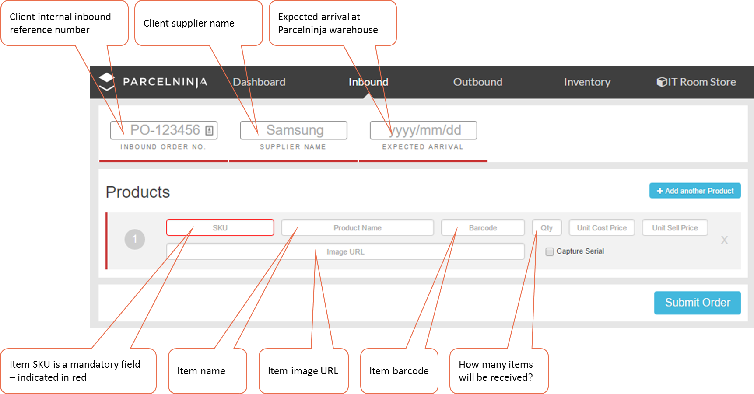Adding an inbound via self-service web interface

Inbound Events
After requesting an inbound the order will have one of the following statuses:
- Order is at Pre-Receiving (Code: 201)
- Order has been Received (Code: 203)
http://docs.parcelninja.apiary.io/#reference/inbounds/list-of-inbounds/retrieve-inbounds

Inventory

Warehousing
Parcelninja will hold a client’s stock in the warehouse until such time as an outbound request is created, when the stock is picked, packed and shipped to the shopper. The outbound will only be fulfilled once there is stock to match the entire outbound order.
Damaged or excess stock can be returned to the client’s supplier via an outbound request.

Inbound Receiving
- Drop off – stock delivered by client’s supplier
- Pre-receive – confirmation that stock was dropped off at warehouse (inbound documentation required for this step)
- Receive & Quality Control
  - Take inbound document and find shipment on system (if no document exists, the shipment must have an invoice or delivery note - lookup shipment)
  - Unpack boxes and split into SKU (staging area)
  - Scan item (or lookup) and perform QC
    - Check Quantity (variances are recorded in system)
    - Check Quality (damages are recorded in system)
    - Check packaging (must pass a "Four Foot Drop Test" and a "Vigorous Shake Test")
    - Check barcodes (generate and print barcodes if missing)
    - Record dimensions and weight in system
    - Review colour, sizes and item names for discrepancies.
    - Confirm item reconditioned
    - Confirm shipment received
- Put stock away
Clients can check their stock counts by requesting the stock on a specific SKU, multiple SKU, or on the entire warehouse. A daily stock take can be taken after hours via the API.
http://docs.parcelninja.apiary.io/#reference/inventory/list-of-inventory/retrieve-full-inventory
A Client can search a subset of Inventory, this endpoint retrieves information about a supplied list of SKUs, and can be paginated, sorted and filtered for ease of use.

Status Updates/Stock Levels
While the stock is in the warehouse, the stock levels will be updated to allow clients to understand their physical stock levels and maintain their product and order management systems appropriately.

Calling Stock Levels
It is important to consider when the stock level information is called via the API. API calls are limited to 2 000 per hour, so best practice advises that this check should be run when the shopper enters the checkout page.
Warehouse inventory will be displayed in one of the following states:

Stock States
State | Description
instock | Items are in the warehouse, have not been assigned to any orders and are available to be assigned.
allocated | Items have been allocated to an Outbound order but have not yet been packed.
unallocated | Outbound orders have been created for these items and there are none available, or they are en-route to the warehouse.
onReorder | Items are en-route to the warehouse.
broken | Items are broken and unsellable, can be returned to supplier.
reserved | Items are in the reserved pool.
http://docs.parcelninja.apiary.io/#reference/inventory/retrieve-full-inventory

Courier

How Much Will It Cost?
Parcelninja leverages its economies of scale by combining client’s outbound volumes to take advantage of the economies of scale of having larger volumes. Deliveries to grouped locations can also be combined to ensure that the costs are kept low.
Costs can be calculated manually on the web interface, or automatically via the API. the detail used to calculate these costs is;
- Parcel dimensions – weight, volume
- Destination – split according to major centre or outlying region
The parcel parameters are determined based on the historical dimensions linked to the product SKU or the dimensions provided by the client, these are then linked to the product SKU and used in the cost calculation. Without the linkage an accurate quote cannot be given, and the client risks incurring extra costs.
The Parcelninja is also able to take the collection address into account when calculating courier costs, should this be required for returns.
Parcelninja will update the parcel status information to the client based on the statuses provided by the couriers.
If an outbound is created on the web front-end it will automatically select the cheapest delivery option.

The API Address Benefits
The Parcelninja API allows the shopper to lookup their address on the clients site while populating the data from the Parcelninja database. This ensures that the shopper selects an address that is recognized by the potential courier, ensuring delivery accuracy.
As Parcelninja does not deliver to PO Boxes, using the Parcelninja address information ensures that a shopper does not select a PO Box.

Options
Once a shopper has confirmed their order items and destination, the Parcelninja API is able to offer a range of delivery options from various couriers based on the specific parcel parameters. At this point a Quote ID is created, this is then used as the unique identifier between the courier and Parcelninja.

Outbound
There are two types of outbound:
- Shopper delivery – which is programmed to only select from unbroken stock.
- Delivery to supplier – which is programmed to select broken stock first.
It is important to understand at this point that an outbound is not the same as an order. An order relates to the order that a shopper has placed, and an outbound is a shipping request. An outbound is tied to a single delivery address but can have multiple SKU’s. If the SKU’s in an order are not all available, multiple outbounds will have to be created.

Dispatch
Parcelninja will manage the dispatch process based on client-created outbound requests, leveraging their technology to simplify the cost calculation and address management details.

Outbound Acceptance Criteria
In order for an outbound to be accepted by Parcelninja, it needs to include the following information:
- List of SKU’s to be sent out – SKU’s that are not physically in stock can be provided, however the outbound will then wait until those SKU’s have arrived before the picking can start.

Manual Process
If a client decides not to use the Parcelninja API, they can manually create the outbound on the site, or by uploading a CSV.
The CSV needs to be in the below format:
Order Number | Channel Order Number | Name | Email | Phone Number | Address Line 1 | Address Line 2 | Suburb | Province | Post Code | Collection | SKU | Item | Quantity
Outbound1 | Outbound1 | Customer Name | someone@email.com | 011 555 7896 | 1 Neverland Road | Somewhere | Bryanston | Gauteng | 2191 | 0 | AAA | Product 1 | 1
Outbound1 | Outbound1 | Customer Name | someone@email.com | 011 555 7844 | 1 Neverland Road | Somewhere | Bryanston | Gauteng | 2191 | 0 | BBB | Product 2 | 1
Outbound2 | Outbound2 | Customer Name 2 | someone2@email.com | 011 555 7824 | 2 Neverland Road | Somewhere | Bryanston | Gauteng | 2191 | 1 | AAA | Product 1 | 2

An outbound can be created in the self-service web interface:
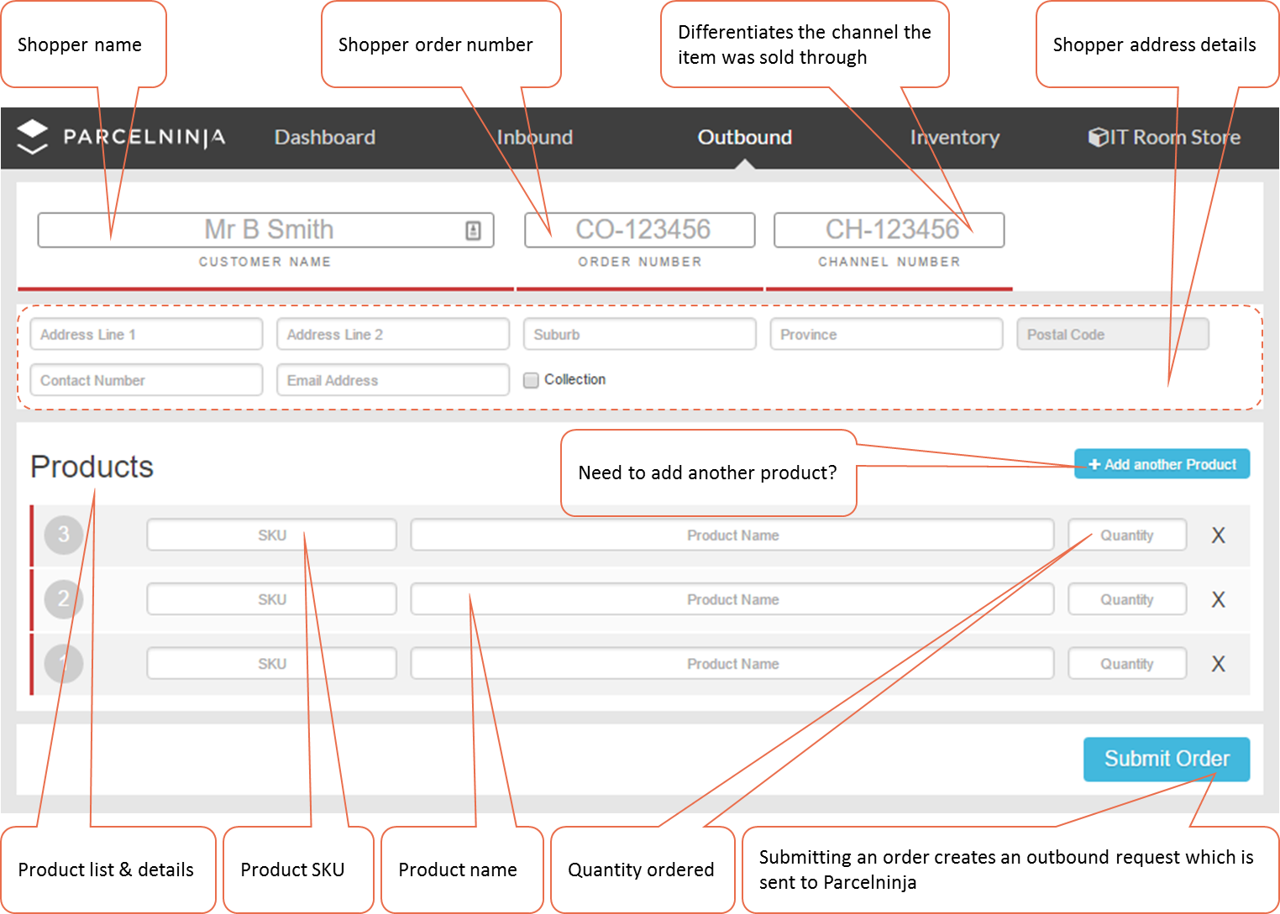
Creating an outbound via self-service web interface

Outbound Cancellation
An outbound can only be cancelled before the pick starts. In order to make changes to an order, the entire outbound needs to be cancelled and re-created with the new conditions.
It is important to understand here that if an outbound is cancelled, the stock will go back into the ‘instock’ status and will therefore be made available for the next outbound in the list.

Split Order Handling
A split order occurs in the following situations;
- products in the same order are not from the same supplier
- products in the same order are not all in stock
- or a partial send
An order can be split during checkout, or after payment if stock levels have changed and order items are no longer in stock. This is an important consideration in ensuring that stock levels are confirmed on checkout to reduce possible split orders and risking the ease of the online shopping experience.
If an order needs to be split after the outbound request has been created, the outbound will need to be cancelled and new ones generated for each delivery. As mentioned above outbound changes can only be made before the pick starts.

Outbound Events
- Order is ready to be picked (Code: 241)
- Order is awaiting courier pickup (Code: 243)
- Order has been Collected (Code: 247)
- Order has been Delivered (Code: 245)
Shoppers can also collect their parcels at Parcelninja (Code: 247)
http://docs.parcelninja.apiary.io/#reference/outbounds/list-of-outbounds/retrieve-outbounds
Stock assignment is automatic and allocates outbounds with outstanding items with items which are unassigned – when all items for an outbound are allocated we can proceed to pick and pack the order.

Tracking
There are a few ways that a Client can check the status of their shoppers’ deliveries, they can search for the outbound in the self-service web interface or they can use the API and webhooks to get a status update.
http://docs.parcelninja.apiary.io/#reference/tracking/track-waybill/track-waybill

Tracking Statuses
Code | Name | Description
Inbound order tracking codes
201 | Order is at Pre-Receiving
203 | Order has been Received
Outbound order tracking codes
241 | Order is ready to be picked
243 | Awaiting courier pickup | Awaiting courier pickup
244 | Dispatched with courier | Dispatched with courier
245 | Delivered | Delivered
247 | Order has been Collected
280 | Unable to deliver | Unable to deliver
Courier tracking codes
300 | En-route with courier | Scheduled for delivery with courier
http://docs.parcelninja.apiary.io/#reference/logs/specific-log/create-callback-hook

Exclusions
- Parcelninja is not able to handle client orders to their suppliers, so an inbound request should only be created once an order has been placed and confirmed with the client’s supplier.
- Parcelninja cannot confirm that a shopper’s payment has been received by the client, so it is up to the client to ensure that payment has been received before an outbound request is created.
- Parcelninja does not deliver to Post Office Address boxes (PO Box).

SLA’s & Business Rules

Quotations
No. | Case | Response | Guaranteed*
 |  |  | Price | Date
0 | All items are in stock – i.e. we know their dimensions | List of quote options  With nominated date options | True | True
1 | Some items are in stock and the ones not in stock has historical dimensions. | List of quote options  No nominated options | True | False
2 | Some items are in stock and the ones not in stock don’t have historical dimensions (supplied in outbound request). | List of quote options  No nominated options | False | False
3 | No items are in stock and only dimensions are provided. | List of estimates  No nominated options | False | False
4 | Dimensions needed but not provided. | Error
* Guaranteed dates and prices are returned as part of the delivery quote object, unguaranteed prices and dates are left empty

Outbound Dates
In the case where all items are in stock (case 0 in the above table) assignment is immediate after outbound creation:
- If assignment completes before 14:00 on a working day, the dispatch date will be the current working day.
- If assignment completes on or after 14:00 on a working day, dispatch date will be the next working day.
- If assignment completes anytime on a non-working day, dispatch date will be the next working day.
*This will apply to orders of 10 items or less only.
In all other cases:
Parcelninja wait until all items needed are in stock and has been assigned to the given outbound then we follow the same logic as outlined above.
Once packed the latest ETAs for a given outbound are available from:
https://www.parcelninja.co.za/api/v1/outbounds/idO OR https://www.parcelninja.co.za/api/v1/tracking/waybillNo
These ETA’s are covered by a 95% SLA – 95% of orders will have a first delivery attempt within the delivery start date and delivery end date given. Note regional or outlying areas are excluded from this SLA, as these are often serviced only on certain days of the week and most often are handled by third party couriers.

Capacity
The Parcelninja system monitors both the capacity of the warehouse as well as the capacity of each courier Parcelninja has integrated with (calculated across all clients for a given dispatch date).
If the warehouse capacity for a given working day is reached or couriers no longer have capacity remaining for that dispatch date the current working day is incremented by 1 day i.e. Parcelninja will be unable to process any new outbounds created after this point, even if all items are in stock, and so orders will be picked and packed the next business day.
Each time capacity is subsequently reached the current working day is incremented by 1 – ensuring expectations are correctly set even in the busiest shopping seasons, allowing orders to queue up for subsequent days, rather than rejecting orders when capacity is reached.
This is normally only an issue at busy times of the year i.e. Black Friday, Cyber Monday, Before Christmas – Parcelninja scale up the warehouse for these occasions, increasing the overall capacity per day to ensure that the impact is reduced. With sufficient notice (1 week) Parcelninja can scale up if need be for specific sale days.

Prices
In case 0 the price is guaranteed, so the price associated with the delivery quote will be the final price invoiced for that order.
There are also cases where price is not guaranteed, the delivery cost is subject to change and will only be fixed once an invoice is available.
An estimate of this cost can be periodically retrieved using the endpoint: https://www.parcelninja.co.za/api/v1/outbounds/id once an invoice is available it will appear as part of the response for this same endpoint.

Postbacks/Webhooks

Why Use Webhooks?
Setting up webhooks allows Parcelninja to update stock and order statuses as they change. This reduces the requirement for clients to constantly poll Parcelninja for stock and order updates.
The statuses of stock and orders is detailed in in the Inventory and Tracking sections of this document.

Preparing for Webhooks
Web facing API, or in other words a web accessible endpoint, in order to receive webhook calls over HTTP.
More technical detail around the specifics of preparing for webhooks can be found at the below link:
http://docs.parcelninja.apiary.io/#reference/webhooks/create/create-callback-hook

Data Definitions

Inbound Data Requirements
Header | Example
- SKU | AAA
- Barcode | AAA
- Product Name | Test Product 1
- Qty | 10
- Unit Cost Price | 150
- Unit Sell Price | 200
- Image URL | http://www.test.co.za/images/image1.jpg

Outbound Data Requirements
Header | Example
- Order Number | Outbound1
- Channel Order Number | Outbound1
- Name | Customer Name
- Email | someone@email.com
- Phone Number | 011 555 7896
- Address Line 1 | 1 Neverland Road
- Address Line 2 | Somewhere
- Suburb | Bryanston
- Province | Gauteng
- Post Code | 2191
- Collection | 0
- SKU | AAA
- Item | Product 1
- Quantity | 1

Supporting Information
Additional process flows & information where required.

Glossary
Term | Definition
Client | Refers to online shop/website owner
First Delivery Attempt | A first delivery attempt is classified as successful delivery or a delivery failure outside of the courier’s control e.g. client was not home, client has moved. If client changed the delivery location or arranged for a differently delivery time after the fact this is outside of our control and therefore not included in the SLA.
Holding | Holding or keeping stock on hand for a client
Inbound | Creating a request for stock to be added to the current warehouse stock
Outbound | Creating a request for stock to be removed to the current warehouse stock
Packing | The process of packaging items for a shopper order
Picking | The process of gathering items for a shopper order
Return | A return occurs when a client’s customer, the shopper, returns a product
Shopper | Refers to customer shopping online shop
Supplier | A suppler as defined in this document is the client’s supplier
Tracking | Tracing the progress of a parcel en route to a shopper

Product Mapping
Information on a specific product’s status throughout the process is available and can be viewed using the product SKU number, or order number depending on where the product is in the fulfilment process.
Product fulfilment process

